Figures & Tables to update/modify/reproduce from Lenny et. al.
Table 1: Summary Statistics
They do weighted and equally weighted, could do the same or not
They have asset/liabilities; unfunded liabilities/payroll; total pension contributions/payroll; active members/retired members; projected percent active member growth; # observations
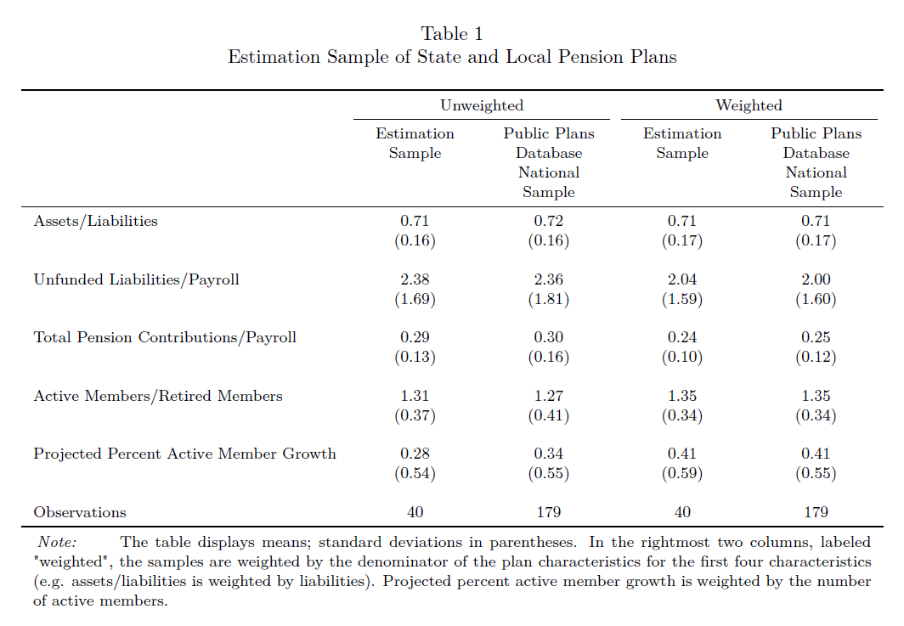

Table 2: percentage point increase in contribution rate required (for different stabilization goals, as function of assumed real rate of return)
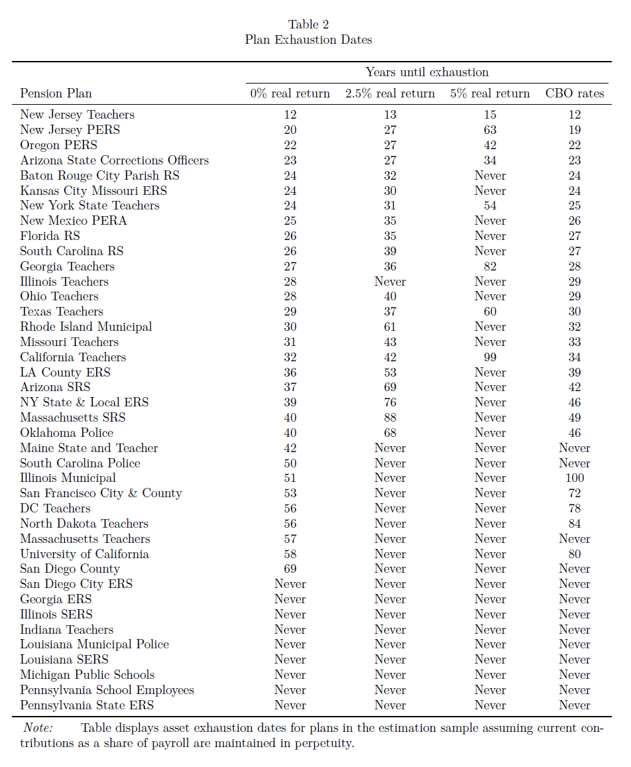
We should think about what our metric in the same spirit would be, e.g., percentage point increase in contribution rate required to bring probability of experiencing a shortfall within next 20 years to less than .5%; 1%; 3%.
This is a description of what would make sense plan by plan to show. Not sure this is a good number to report unconditionally across plans. Maybe report it in aggregate for plans that are underfunded by some minimum percentage amount, e.g., 20%. This idea of experiencing a shortfall over some period is a cumulative notion. It would be counting the fraction of sample paths that ended in insolvency over each horizon. See notes below on their Figure 6 also.

Figure 1 Average S&L funding ratios using AAA corporate bond rates, 2002 to 2018.
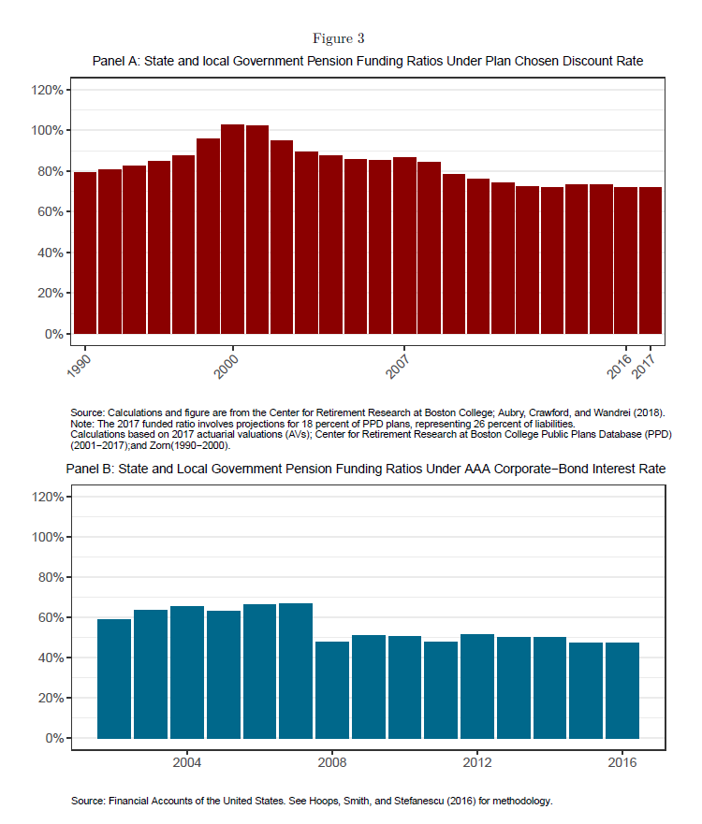We probably want to show both official and AAA-discounted funding ratios. Can May help us get this from historical data, BC, Rauh, or elsewhere? Lenny paper gets #s from Financial Accounts of the United States and cites Hoops, Smith and Stefanescu (2016).
Could compare the # of surprise crises with the different measures to maybe support idea that AAA ratio is somehow more telling (although if one is just a stable fraction of the other, it wouldn’t make that much difference).

Figures 2, 3 & 4 are macro/demographics; don’t need to revisit
?

Figure 5 pension assets to GDP
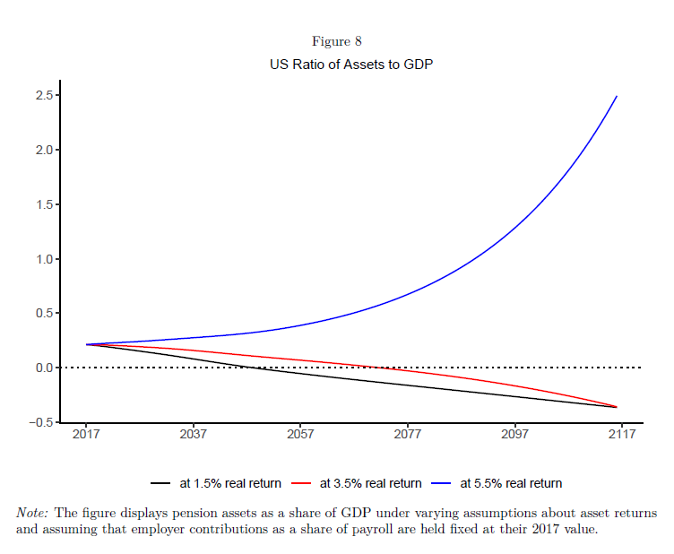
Also not relevant because not assessing aggregate burden and because problems with asset return assumptions in original

Figure 6
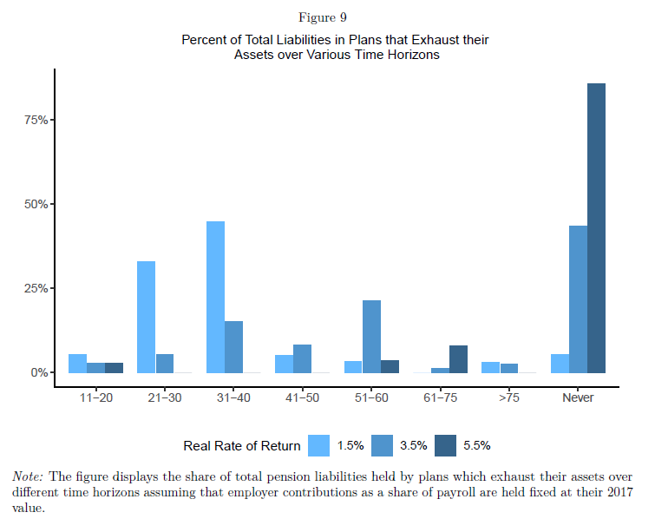
Percent of total liabilities in plans that exhaust their assets over various time horizons as a function of constant assumed rate of return. Percentage of total liabilities AND value of total liabilities in plans that exhaust in different years could be a good way to illustrate aggregate magnitudes, and doesn’t require just looking at plans already below some funding ratio as suggested in Figure 2 notes above. But overall paper emphasis will be more on Figure 2 cross-section.

Figures 7,8 looks at liabilities to GDP under different start dates for stabilizing that ratio with a permanent increase in contributions that accomplishes stabilization.
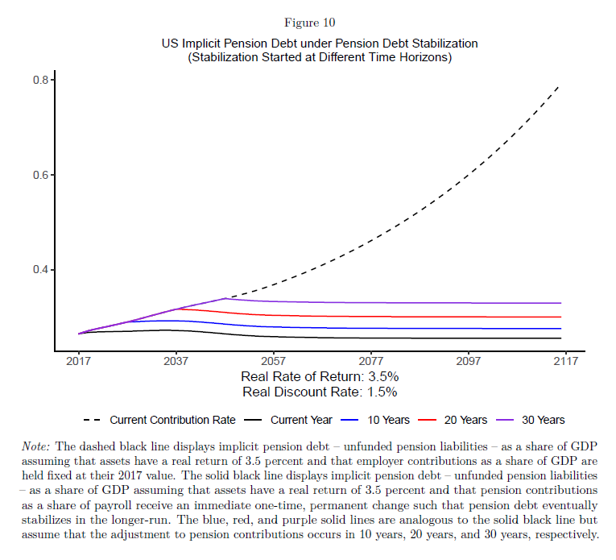
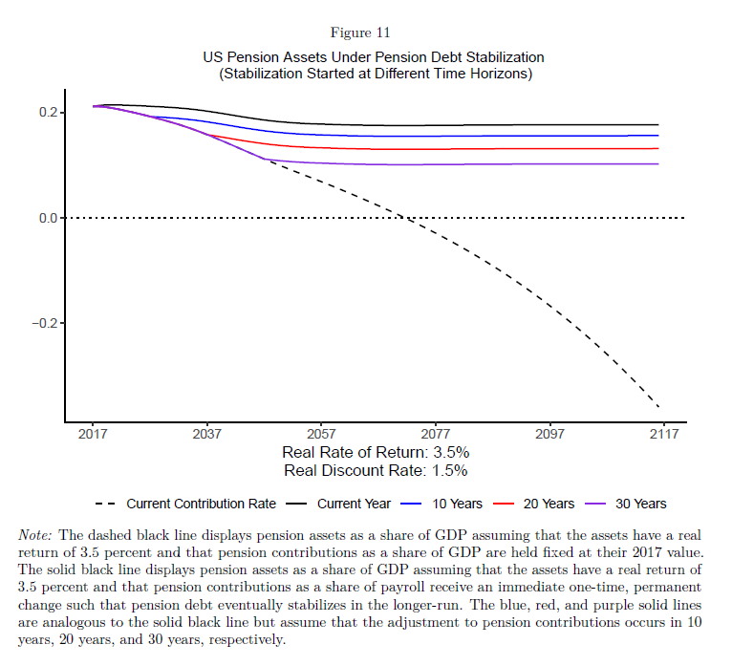
This sort of question is addressed in the notes above to Figure 2, suggesting we see how much contribution rates would have to rise to keep the likelihood of exhaustion over some horizon below some threshold. We could ask, how much higher would the future contribution have to be to stabilize this under (1) a variety of investment strategies; and (2) under a variety of waiting periods to start increasing contributions (immediate; 5 years; 10 years; 15 years; 20 years).

Figure 9
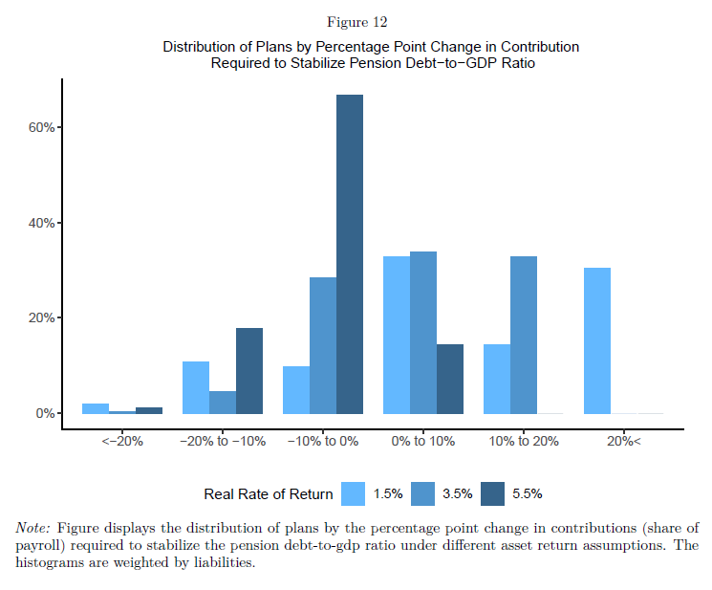
Shows distribution of contribution rate increases (as share of actuarial liabilities) to achieve different measures of stability. We could similarly show distribution of contribution rate increases to achieve threshold probability for solvency over preferred horizon.

Figure 10 is more interesting. It is a scatterplot of needed funding increase to achieve stability goal by funded ratio, with a regression line. We can do the analogous plots for whatever we choose to define as stability targets. Also to see how this varies with different investment strategies.

Figure 11 looks at effects of pension plan reforms on what is needed for stabilization. They ask, had recent reforms not happened, how much more would contributions have to be raised to stabilize? They report this by plan, divided between benefit reforms that were undertaken and changes in contribution rates that have already happened since 2007.
This is interesting. We will have to discuss how we want to measure policy changes. For instance, we could look at what would happen without Tier changes after some date. Do we have their data on changes in contribution rates over time?

Figure 12 gets at the same sort of thing.

